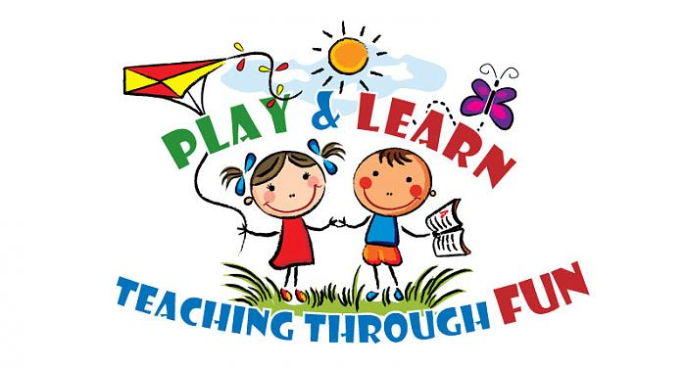
2015-2016
Come to Play ‘N’ Learn with your child at the ELC!

Free for families with children ages birth to 4 years old.
Explore New Toys Meet New Families Enjoy Story Time Creative Art Experiences
Enjoy Playing With Your Child

*FOR ELC STUDENTS: PLEASE NOTE THAT THESE CLASSES ARE INTENDED FOR PARENTS TO ACCOMPANY THEIR CHILDREN WHILE THEY ARE NOT IN CLASS. WE WON’T PULL CHILDREN OUT OF CLASS TO ATTEND PLAY ‘N’ LEARN SESSIONS.

Schedule:
Week One: Jan 12th & Jan. 14th Week Two: Jan. 26th & Jan. 28th
Birth to 2yr. | 3yr. to 4yr. | Birth to 2yr. | 3yr. to 4yr.
Morning Schedule:  English Class  Jan. 12th  9:30-10:30  Afternoon Schedule:  Spanish Class  Jan. 12th  12:30-1:30 | Morning Schedule:  English Class  Jan. 14th  9:30-10:30  Afternoon Schedule:  Spanish Class  Jan. 14th  12:30-1:30 | Morning Schedule:  Spanish Class  Jan. 26th  9:30-10:30  Afternoon Schedule:  English Class  Jan. 26th  12:30-1:30 | Morning Schedule:  Spanish Class  Jan. 28th  9:30-10:30  Afternoon Schedule:  English Class  Jan. 28th  12:30-1:30

Week Three: Feb. 16th & Feb. 18th Week Four: Mar. 1st & Mar. 3rd
Birth to 2yr. | 3yr. to 4yr. | Birth to 2 yr. | 3yr. to 4yr.
Morning Schedule:  English Class  Feb. 16th  9:30-10:30  Afternoon Schedule:  Spanish Class  Feb. 16th  12:30-1:30 | Morning Schedule:  English Class  Feb. 18th  9:30-10:30  Afternoon Schedule:  Spanish Class  Feb. 18th  12:30-1:30 | Morning Schedule:  Spanish Class  Mar. 1st  9:30-10:30  Afternoon Schedule:  English Class  Mar. 1st  12:30-1:30 | Morning Schedule:  Spanish Class  Mar. 3rd  9:30-10:30  Afternoon Schedule:  English Class  Mar. 3rd  12:30-1:30

------------------------------------------------------------------------------------------------------------------------------------
Parent Name: ________________________________________________________________________________

Child’s Name(s):_________________________________________________________________________

Age(s): ________________________________________________________________________________________

Session I would like to attend (date & time): ______________________________________________

Contact Information: ________________________________________________________________________

Please contact Marlyn Orozco, Family Facilitator at 847-472-3677 to register for the class or simply fill out the bottom portion of this form and return to the Early Learning Center. Thank you.

